Corner

Definition
# Source: AI Source: Provided by: [Data Path: Persons Table -> ID Column: 1, Name_En Column: Motasem Essam] -> From: [ChatGPT] on [7/25/2026]
A corner is a point or location where two or more line segments, edges, sides, or surfaces meet.
In geometry, a corner is commonly represented by a vertex.
For example, in a polygon, each corner is a vertex:
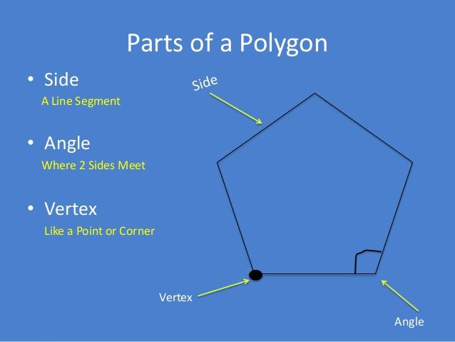
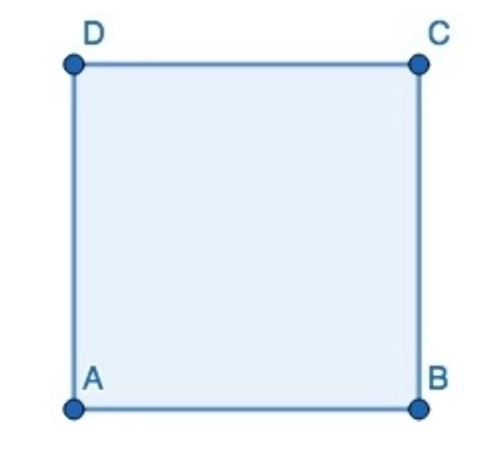
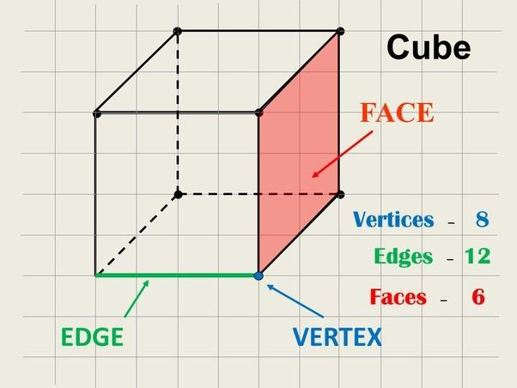
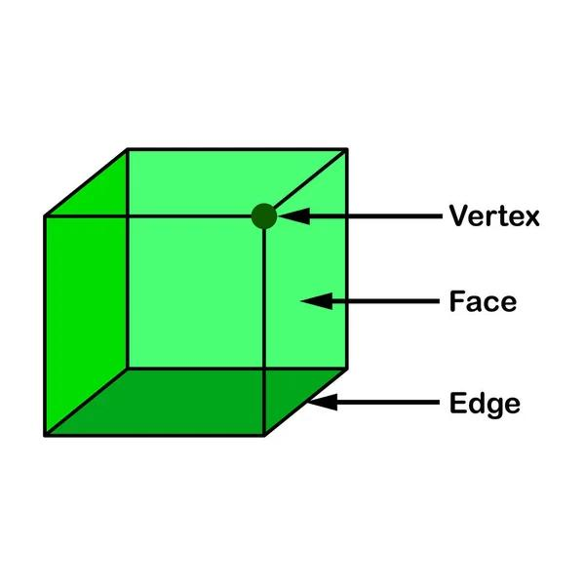
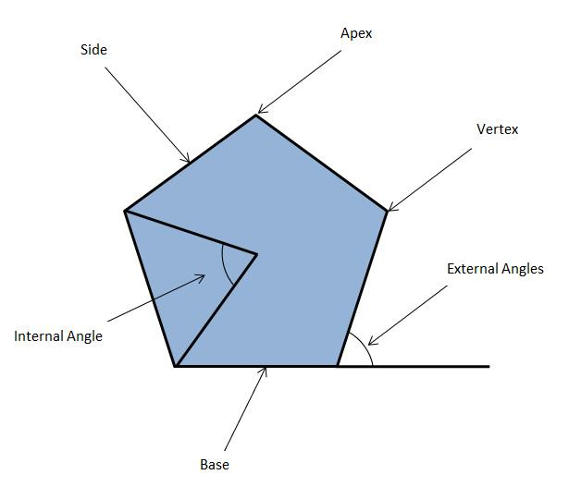

Example
# Source: AI Source: Provided by: [Data Path: Persons Table -> ID Column: 1, Name_En Column: Motasem Essam] -> From: [ChatGPT] on [7/25/2026]
A square has 4 corners, and therefore it has 4 vertices.
If the square is named $ABCD$, its corners are:
$$A, B, C, D$$

Corner vs. Vertex
# Source: AI Source: Provided by: [Data Path: Persons Table -> ID Column: 1, Name_En Column: Motasem Essam] -> From: [ChatGPT] on [7/25/2026]
In elementary geometry, corner and vertex are often used to describe the same location, but vertex is the formal mathematical term.
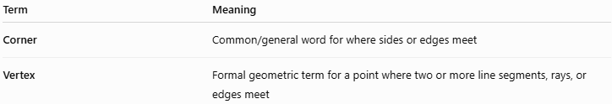
Term | Meaning
Corner | Common/general word for where sides or edges meet
Vertex | Formal geometric term for a point where two or more line segments, rays, or edges meet
For example:
$$△ABC$$
has three corners, formally called three vertices:
$$A, B, C$$

Corners in Different Geometric Figures
# Source: AI Source: Provided by: [Data Path: Persons Table -> ID Column: 1, Name_En Column: Motasem Essam] -> From: [ChatGPT] on [7/25/2026]
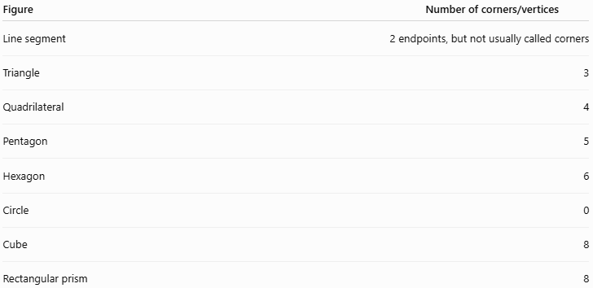
Figure | Number of corners/vertices
Line segment | 2 endpoints, but not usually called corners
Triangle | 3
Quadrilateral | 4
Pentagon | 5
Hexagon | 6
Circle | 0
Cube | 8
Rectangular prism | 8
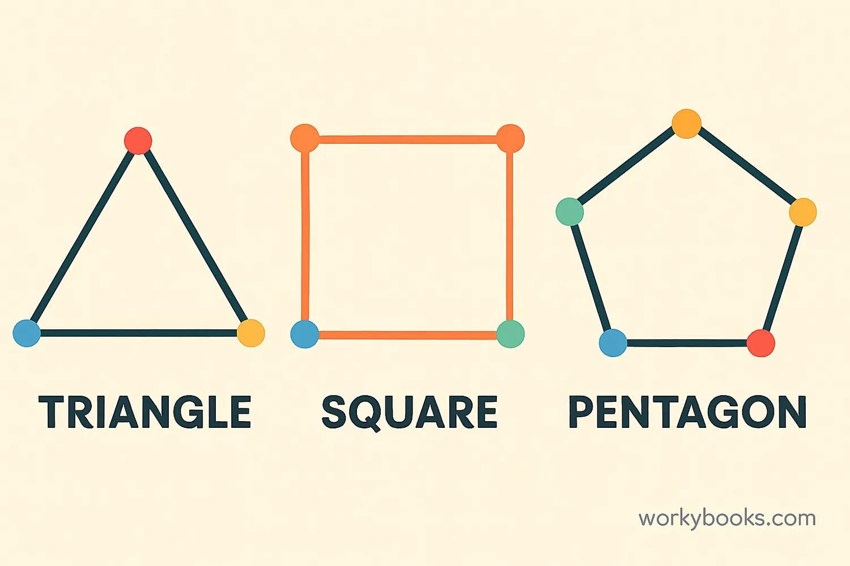
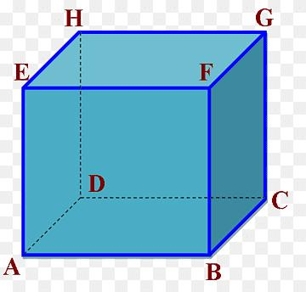
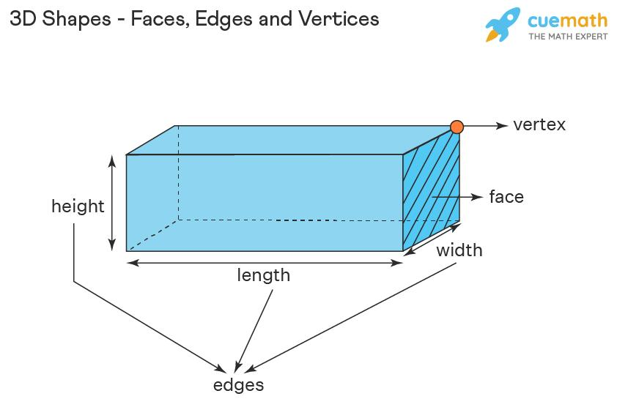
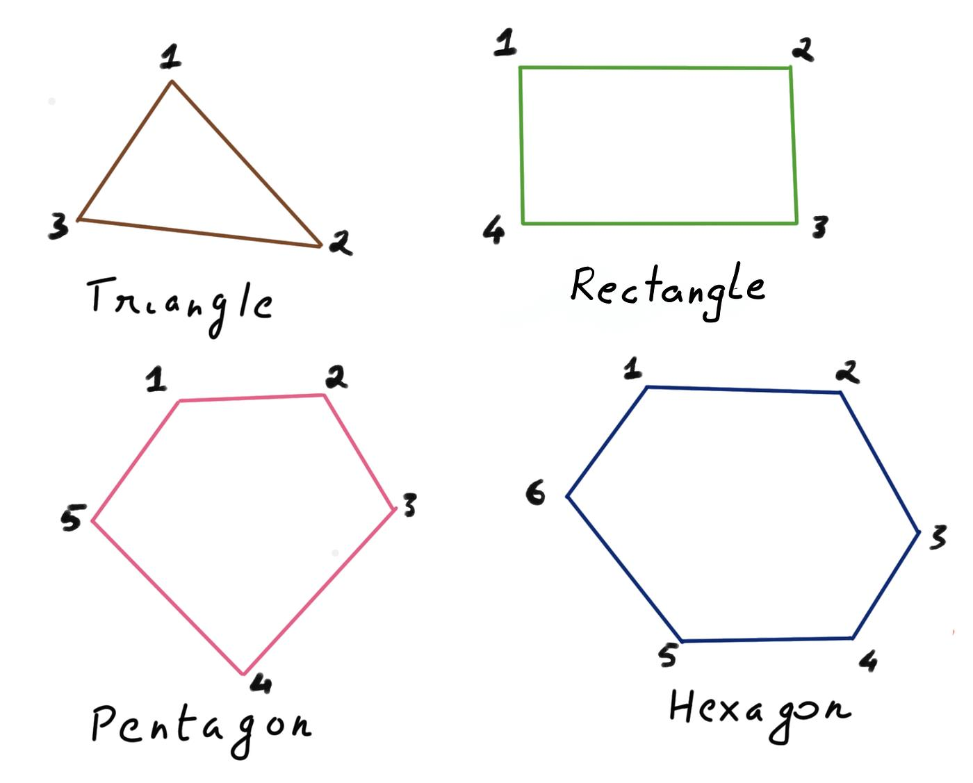
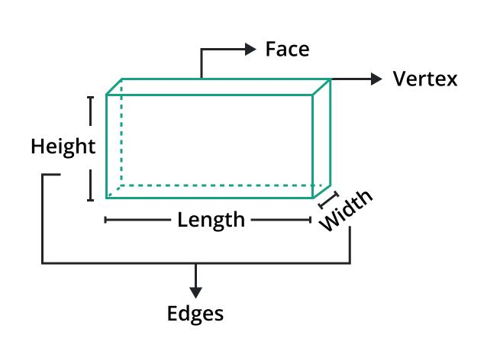
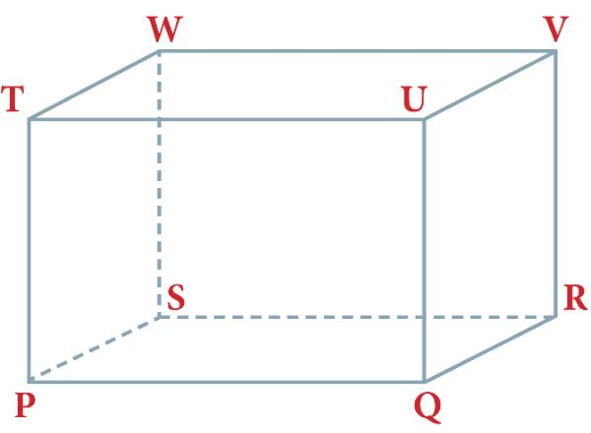

Corner in 2D Geometry
# Source: AI Source: Provided by: [Data Path: Persons Table -> ID Column: 1, Name_En Column: Motasem Essam] -> From: [ChatGPT] on [7/25/2026]
In a 2D figure, a corner usually occurs where two sides meet.
For example, at vertex $B$:
$$\overset{‾}{AB}\text{ and }\overset{‾}{BC}$$
meet at $B$.
The meeting point $B$ is the corner/vertex.

Corner in 3D Geometry
# Source: AI Source: Provided by: [Data Path: Persons Table -> ID Column: 1, Name_En Column: Motasem Essam] -> From: [ChatGPT] on [7/25/2026]
In a 3D solid, a corner is where three or more edges meet.
For a cube, each corner is a vertex.
At a typical cube vertex, three edges meet:
$$\overset{‾}{AB}, \overset{‾}{AD}, \overset{‾}{AA^{'}}$$
Thus, a cube has:
- 8 vertices (corners)
- 12 edges
- 6 faces
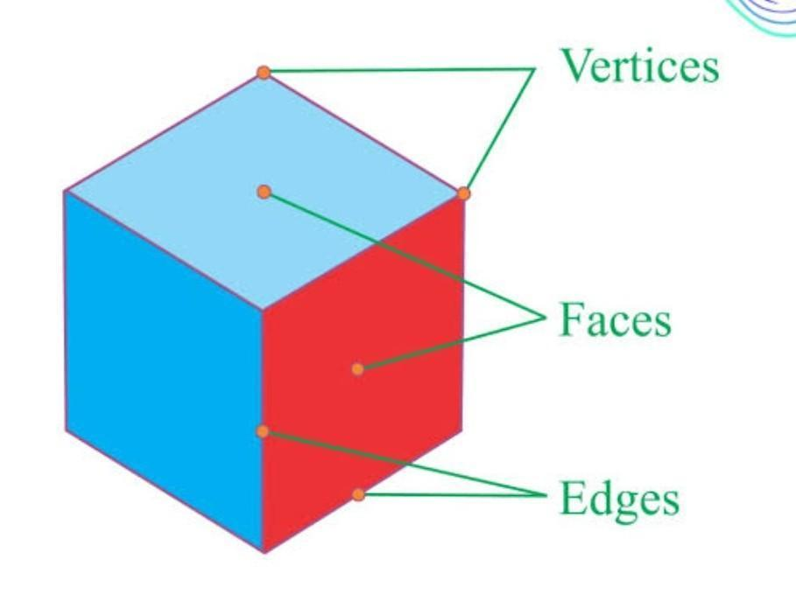
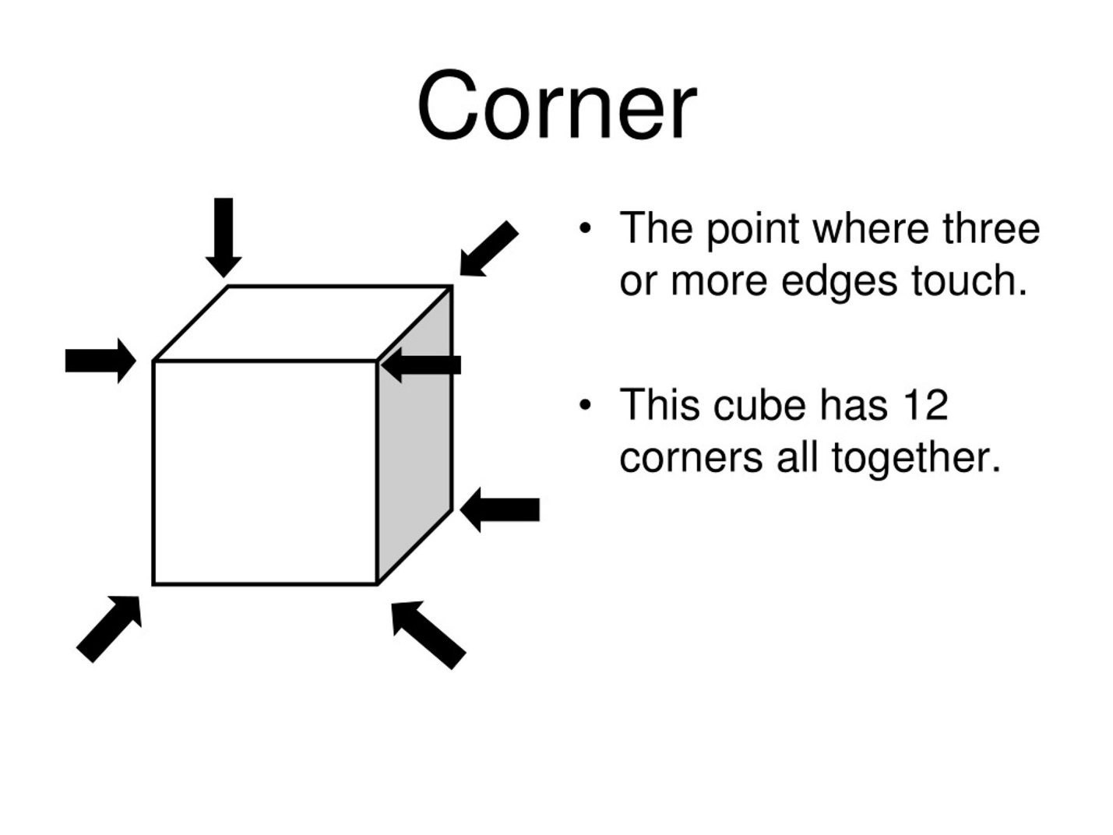
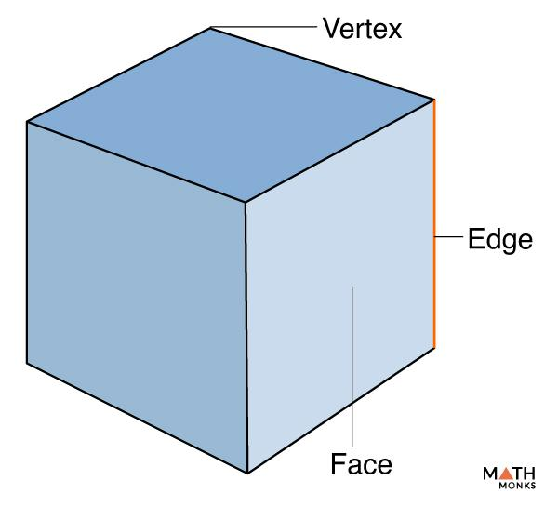
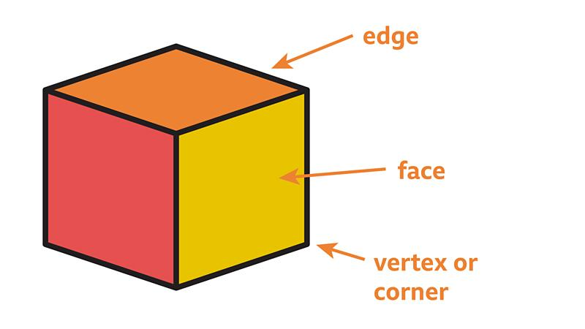

Corner and Angle
# Source: AI Source: Provided by: [Data Path: Persons Table -> ID Column: 1, Name_En Column: Motasem Essam] -> From: [ChatGPT] on [7/25/2026]
A corner often forms an angle.
For example, two rays:
$$\vec{BA}$$
and
$$\vec{BC}$$
meet at $B$.
Therefore:
$$∠ABC$$
is the angle at the corner $B$.
So:
Corner/vertex → location where sides meet
Angle → amount of turning between the sides

Types of Corners by Angle
# Source: AI Source: Provided by: [Data Path: Persons Table -> ID Column: 1, Name_En Column: Motasem Essam] -> From: [ChatGPT] on [7/25/2026]
A corner can form different types of angles.
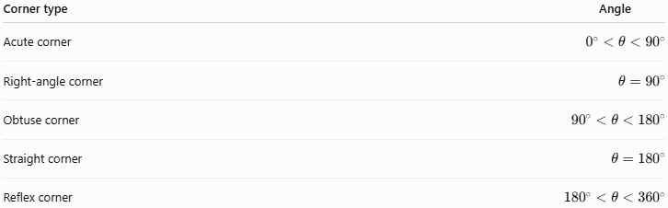
Corner type | Angle
Acute corner | $$0^{∘}<θ<{90}^{∘}$$
Right-angle corner | $$θ={90}^{∘}$$
Obtuse corner | $${90}^{∘}<θ<{180}^{∘}$$
Straight corner | $$θ={180}^{∘}$$
Reflex corner | $${180}^{∘}<θ<{360}^{∘}$$
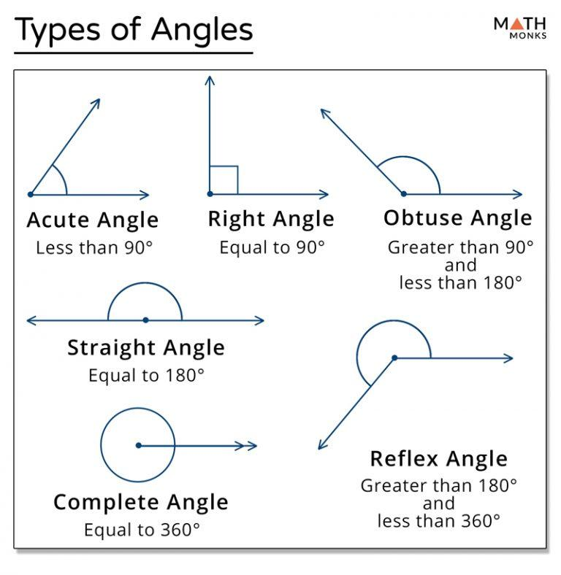
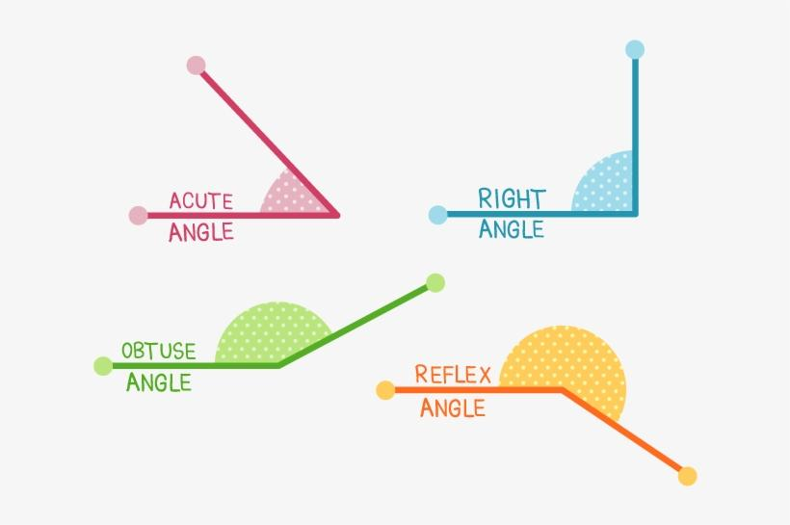
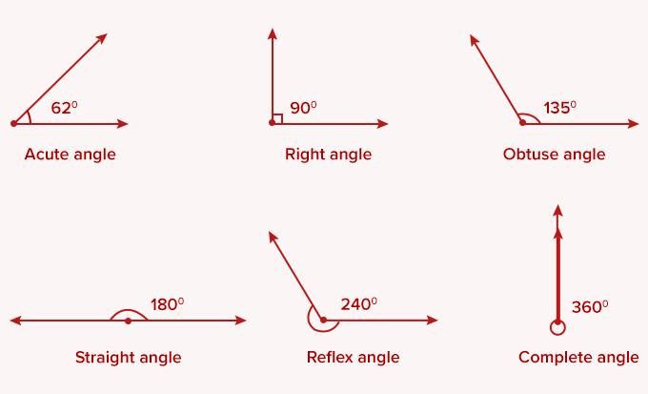

Important Distinction
# Source: AI Source: Provided by: [Data Path: Persons Table -> ID Column: 1, Name_En Column: Motasem Essam] -> From: [ChatGPT] on [7/25/2026]
Not every point where lines meet is necessarily called a corner.
For example, two lines can intersect:
$$l_{1}∩l_{2}=P$$
The point $P$is an intersection point, but in formal geometry it is not necessarily described as a corner.
The word corner is especially appropriate for:
- polygons
- polyhedra
- physical objects
- surfaces
- rooms
- buildings
The formal mathematical term is usually vertex.

Real-World Examples
# Source: AI Source: Provided by: [Data Path: Persons Table -> ID Column: 1, Name_En Column: Motasem Essam] -> From: [ChatGPT] on [7/25/2026]
Corners are found in:
- corners of a room
- corners of a table
- corners of a sheet of paper
- corners of a box
- corners of a building
- corners of a road intersection
- corners of rectangular screens

Key Points
# Source: AI Source: Provided by: [Data Path: Persons Table -> ID Column: 1, Name_En Column: Motasem Essam] -> From: [ChatGPT] on [7/25/2026]
- A corner is where two or more sides, edges, or surfaces meet.
- The formal geometric term for a corner is usually vertex.
- A triangle has 3 corners/vertices.
- A square has 4 corners/vertices.
- A cube has 8 corners/vertices.
- A corner of a polygon usually forms an angle.
- A circle has no corners or vertices.

Conclusion
# Source: AI Source: Provided by: [Data Path: Persons Table -> ID Column: 1, Name_En Column: Motasem Essam] -> From: [ChatGPT] on [7/25/2026]
Corner is a general term for a point where parts of a geometric figure or physical object meet. In formal geometry, the corresponding term is usually vertex. In 2D figures, a corner occurs where sides meet; in 3D solids, it occurs where edges meet.

